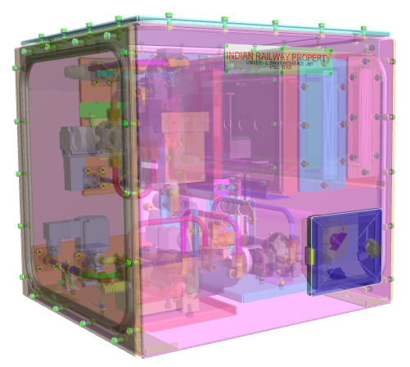
HBL Power Systems Ltd, India | Technical Description for  Universal Brake Interface Unit

TECHNICAL DESCRIPTION OF
UNIVERSAL BRAKE INTERFACE UNIT (UBIU)

for

TCAS / DPCS / DPWCS / TSS

Document Number: 5 16 27 0038
Version: 1.4

Date Published: 15/11/2019

Prepared By
HBL Power Systems Limited
Hyderabad
This document and its content are the property of HBL Power Systems Ltd, who alone reserves the right for distribution use and reproduction

DOCUMENT DATA SHEET

Title of Document | File Name | Pages | Figures | Tables
Technical Description of Universal Brake Interface Unit for TCAS/DPCS/DPWCS/TSS | Technical Description for Universal Brake Interface Unit | 31 | 12 | 7

Prepared by | Reviewed by | Approved by
Y. Subrahmanyam  (Head - Engineering) |   Hemant Sagade  (Safety Manager) | K Pradeep Kumar  (Head - IV&V & QA)

Abstract
This document describes the features and functions of the Universal Brake Interface Unit and explains the design of the same.

DOCUMENT CONTROL SHEET

# | Name | Organization | Function | Level
1 | Y. Subrahmanyam | HBL | Engineering | Prepare
2 | Jagannatharao K | HBL | Engineering | Prepare
3 | Hemant Sagade | HBL | RAMS | Review
4 | Pradeep Kumar K | HBL | IV&V and QA | Approve
CHANGE HISTORY

# | Date | Reason for changes | Updated by | Version
1 | 20/3/2018 | Initial Draft | Y. Subrahmanyam | 1.0
2 | 23/9/2019 | Clause wise compliance Table is updated as per RDSO’s letter SD.DEV.UBIU (M/S HBL) dated 11/9/19.  In the section describing the isolation of UBIU description for external pneumatic isolation cock is added. | Y. Subrahmanyam | 1.1
3 | 03/10/2019 | Functionality for interfacing with DPSC/DPCWS/TSS and TCAS of other vendors is added.  Description for electrical circuit operation is modified along with connectivity diagram. | Jagannatharao K | 1.2
4 | 11/10/2019 | Additional functional requirement added - UBIU fault handling  Requirement of traction cut-off is modified as safety requirement. | Jagannatharao K | 1.3
5 | 15/11/2019 | Minor changes done to sec 8.1.7 and 6.5.7 | Jagannatharao K | 1.4
GLOSSARY OF TERMS
# | Abbreviation | Meaning
 | Addl.C2W | Additional C2 relay valve in the brake circuit
 | A9 | Driver’s automatic brake lever for formation braking.
 | BC | Brake Cylinder
 | B.P | Brake Pipe
 | CAN | Controller area network
 | DCV | Double Check Valve
 | DMI | Driver Machine Interface
 | DPCS - for diesel locos | Distributed Power Control System
 | DPWCS- for electric locos | Distributed Power Wireless Control System
 | EB | Emergency Brake
 | EPC | Electronic Pressure Controller
 | FR | Functional Requirement
 | FSB | Full-Service Brake
 | IRAB | Indian Rail Air Brake
 | L.E | Light Engine
 | LPSR | Low-Pressure Selector Relay
 | LV | Limiting Valve
 | MR | Main Reservoir
 | MU | Multiple Unit
 | NB1 & NB2 | Normal Brake1 and Normal Brake 2
 | P.O.V | Pilot Operated Valve
 | QRV | Quick-Release Valve
 | SA9 | Independent brake Controller for Light engine braking.
 | SR | Safety requirement
 | TCAS | Train Collision Avoidance System
 | TSS | Train Safety System
 | UBIU | Universal brake interface unit

Table of Contents
1.0 SCOPE 8
2.0 PURPOSE 8
3.0 UBIU FUNCTIONAL & SAFETY REQUIREMENTS 8
4.0 BRAKE APPLICATION ON LOCOMOTIVES 13
5.0 UBIU DESIGN DESCRIPTION 14
5.5 Emergency Brake 15
5.6 Light Engine Braking 15
6.0 UBIU – PNEUMATIC CIRCUIT OPERATION 17
6.2 BP Charging / Brake Release 17
6.3 Service Brake Application 17
6.4 Emergency Brake 19
6.5 Light Engine Brake 19
7.0 UBIU – Electrical Circuit 20
8.0 Electronics in UBIU 23
8.1 Brake interface card (BIC). 23
8.2 IDL (Integrated data logger) 24
8.3 BIC power supply card 24
8.4 UBIU Power Supply Card 24
9.0 COMPLIANCE WITH SAFETY REQUIREMENTS 25
9.1 Fail Safety 25
9.2 Health Monitoring 25
9.3 Isolation 25
10.0 Dimensional details of UBIU 27
10.1 Without mounting arrangement 27
10.2 With mounting arrangement 27
11.0 UBIU assembly with pneumatic components 28
12.0 Technical Specification Sheets 29
13.0 Schematic diagram of UBIU interface with an IRAB braking system 31

- SCOPE

  - This document relates to the design of Universal Brake Interface Unit (UBIU), for use on locomotives fitted with IRAB braking system and train control systems like TCAS, DPCS, DPWCS or TSS.

- PURPOSE

  - TCAS is designed to ensure safe train operation in the event of human failure by stopping or controlling the speed of trains.
  - DPCS / DPWCS allows multiple locomotives to be used at different locations over the entire train consist. Such a system allows longer trains to be run, thereby increasing the line capacity.
  - For the sake of brevity, TCAS/DPCS/DPWCS will hereafter be referred to as train control systems.
  - It is necessary for train control systems to be interfaced with the braking system of the locomotive.
  - Under certain circumstances, it is also necessary to isolate the train control system braking and allow the Loco Pilot to operate the locomotive manually.
  - The purpose of this document is to propose the design of a UBIU for train control systems that fulfills the above safety requirements.

- UBIU FUNCTIONAL & SAFETY REQUIREMENTS

  - The functional requirements of UBIU are listed below.

# | Requirements
FR-1 | UBIU shall work in parallel to the existing loco braking system (controlled by the Loco Pilot
FR-2 | UBIU shall not modify the existing braking characteristics of the locomotive (single/MU/Banking) as well as other self-propelled vehicles treated as trains.
FR-3 | The UBIU shall have provision for executing following brake commands  a) Normal Brake command  NB1 – B.P Pressure Drop to 4.5 kg/cm2 from 5 kg/cm2  NB2 – B.P Pressure Drop to 4.2 kg/cm2 from 5 kg/cm2  b) Full Service brake command  FSB1 – Pressure Drop to 3.7 kg/cm2 from 5 kg/cm2  FSB2 – Pressure Drop to 3.5 kg/cm2 from 5 kg/cm2  c) Emergency brake command  EB – Pressure Drop to 0 kg/cm2 from 5 kg/cm2  d) Light engine brake command  Pressure build-up in Brake Cylinders to 3 kg/cm2
FR-4 | Based on the input signal from the train control system through UBIU, the existing brake control system shall apply the corresponding brake, as mentioned at FR-3 above.
FR-5 | Separate solenoid valves shall be used for  1. Normal, full-service brake  2. Light engine braking and  3. The emergency brake.
FR-6 | On withdrawal of brake command from train control system, the corresponding brake shall be released and restoration of traction/throttle cutoff control shall be enabled
FR-7 | There shall be a facility to override the "train control system initiated braking" by the "driver’s braking" (or vice-versa) to achieve higher braking intensity whenever required). Loco Pilot can override and increase braking effort generated by UBIU, but not decrease the same. Also, the lower braking intensity of TCAS shall be overridden by a higher braking intensity produced by other train safety systems, if any. Arrangement for data logging for the above scenario shall be available.
FR-8 | UBIU shall be capable of receiving braking command simultaneously from the Loco pilot through Brake handle as well as from the train control system at the same time. In case of multiple braking requests received simultaneously, the UBIU should implement the command demanding for the highest braking effort.
FR-9 | UBIU shall have provision to obtain feedback from IRAB system about the execution of braking command given to it by train control system and communicate it back to train control system.
FR-10 | UBIU shall have a provision of point to point communication with train control system.
FR-11 | The communication between the UBIU and the train control systems shall be on CAN. CAN communication ports should have galvanic/optical isolation. CAN interface protocol shall be implemented as per Annexure 1 RDSO specification no: MP.0.01.00.31,(Rev.00) December 2014.
FR-12 | HBL’s UBIU shall have a separate RS-485 communication port for communicating with HBL’s TCAS
FR-13 | There shall be provision for both manual and automatic  Isolation of the complete UBIU. Automatic Isolation shall be achieved through a valve electrically operated by the System and the manual isolation shall also be provided in case of malfunction. After isolation, the normal brake characteristics of the locomotive brake system shall not be affected.
FR-14 | The UBIU shall have the facility to isolate itself from the loco pneumatic system through an isolation switch. The isolation shall be achieved through valves electrically operated by the UBIU. The isolation mechanism shall be protected by the provision of a lock and key arrangement to avoid inadvertent isolation.
FR-15 | The Brake unit isolation shall be monitored and its status shall be communicated by UBIU to train control system.
FR-16 | The UBIU shall have a non-resettable counter to register the instances of brake unit getting isolated by the Loco Pilot.
FR-17 | The UBIU isolation switch shall be located on the UBIU such that it is accessible for operation by the Loco Pilot.
FR-18 | Isolation of UBIU shall result in itself getting isolated from the pneumatic system of the loco.
FR-19 | There shall be a provision of manual isolation of the UBIU. Pneumatic inlet pipes (MR & BP) to UBIU shall be provided with isolating gate valves to isolate the unit, in case of internal leakages to avoid loco failure.
FR-20 | The UBIU shall be capable of working on locos of Indian railways fitted with  IRAB 9 &10 on electric locos and IRAB 1 on diesel locos.
FR-21 | UBIU shall have a Self-Test feature for the detection of failed valves/sensors by performing self-diagnosis at power ON and give alerts to a user through train control system display. The UBIU shall have the facility to communicate its diagnostics information to train control system.
FR-22 | UBIU shall have provision for redundant control for emergency brake command, which shall be activated if the default control mechanism fails
FR-23 | - During CAN communication failure for train control system  - UBIU shall not perform brake application of that respective interface.  - Brakes will be released and allow Loco Pilot operations.  - Respective failed train control system node shall go to Pre-operational mode.  - For any internal failure in UBIU following action shall be taken by UBIU.  - UBIU shall not perform brake application. Brakes will be released and allow Loco Pilot operations.  - In case of failure of remote DPCS/DPWCS equipped loco, the action taken is described in section 3.3, FR-32
FR-24 | All supply voltages for operating the UBIU shall be generated from loco battery which shall be in the range 50V to 90V DC for Diesel Electric and range 78V to 136V DC for Electric.

  - Requirements for data logging of braking events generated by equipment connected to CAN ports. (For train control system)

# | Requirement
FR-25 | Recording of UBIU isolation event with date and time and number of counts of UBIU isolation.
FR-26 | Arrangement for data logging for the braking event shall be available with UBIU. The status of following events shall be logged at 1-sec interval/change in events, with date and time stamp  - Train control system brake command active  - Any change in BP / BC greater than 0.3 kg/cm2 to be logged  - Isolation of UBIU  - UBIU failure log  - Self-check  - UBIU Brake command override by Loco pilot brake command, vice versa
FR-27 | An internal battery backup shall be provided for maintaining a real-time clock in the event of failure of power supply. Event recording shall be done in real-time.
FR-28 | The facility for the storage of data log shall be for 90 days. An application running on PC shall be provided for downloading the Log and evaluating the same.
FR-29 | The UBIU should have an arrangement to download events and fault data packs through a common USB port in an external pen drive / LAPTOP.  The UBIU should have an onboard provision to monitor and record the various brake parameters through a laptop.

  - Following are the requirements of UBIU for DPCS/DPWCS equipped locos.
# | Requirements
FR-30 | There shall be a provision of a separate valve in UBIU to cut off BP charging in remote locomotive automatically on receipt of a command from DPCS / DPWCS.
FR-31 | The arrangement shall be such that the BP charging is cut off on 100% basis and valve position feedback shall also be provided for alerting the Loco Pilot in case of any such malfunctioning
FR-32 | The BP charging cut off valve shall be energized when a communication failure occurs between the DPCS/DPWCS equipment of both the locos and when a fault is developed either in DPCS/DPWCS or UBIU in remote loco.
FR-33 | UBIU should be able to measure air flow and communicate to DPCS / DPWCS for the detection of train parting.

  - The safety requirements of UBIU are listed in the following table.

# | Requirements
SR-1 | The emergency brake command shall be fail-safe.
SR-2 | In case of power supply failure to UBIU, the emergency brake shall get activated.
SR-3 | In case of communication failure between UBIU and HBL’S loco TCAS, the UBIU Shall command emergency brake.
SR-4 | In case of critical failure of UBIU electronics interfaced with HBL’s TCAS, emergency brakes shall get activated.
SR-5 | In the case of LE brake application by train control system through UBIU, B.P pressure shall also be controlled (dropped) to ensure safe operation. This is to avoid mishaps that may arise due to the erroneous application of brakes to loco alone while working as a train formation.
SR-6 | In the case of manual isolation of UBIU through the operation of MP and BP cocks, the isolation cocks shall be provided with sensing input connected to UBIU to detect the external pneumatic isolation.  This information shall be communicated by UBIU to respective train control systems to switch to the appropriate mode of operation, as indicated in their respective specifications.
SR-7 | There shall be a provision in UBIU to cut-off traction in electric locomotive or throttle in diesel locomotives automatically whenever brake command signal is received on any of the inputs of UBIU (through train control system). Also, this shall be withdrawn as soon as brake commands are withdrawn.

- BRAKE APPLICATION ON LOCOMOTIVES

  - The brake system on a locomotive has two valves – A9 and SA9, which the loco pilot uses to brake the train. In case the train is a formation, the automatic brake lever A9 is used, while SA9 is used for braking a light engine.

  - The A9 Automatic Brake Valve is a compact self-lapping, pressure maintaining brake valve which is capable of gradual application or release of locomotive and train brakes. A9 Automatic Brake Valve has five positions: Release, minimum Reduction, Full Service, Over Reduction and Emergency. In the Release position, it provides a brake pipe pressure of 5 Kg/Cm². In other positions, the brake pipe pressure is reduced to varying levels according to the required level of braking.

  - SA9 Independent Brake Valve is a compact self-lapping, pressure maintaining Brake Valve which is capable of gradual application or release of Locomotive Air Brakes independent of Automatic Brake. The SA9 Independent Brake Valve is also capable of releasing an automatic brake application on the Locomotive without affecting the train brake application. The SA9 Brake Valve has three positions: quick release, release and application.

- UBIU DESIGN DESCRIPTION

  - In a locomotive, the Loco Pilot adjusts the position of A9 lever to obtain the desired level of braking based on his situational awareness through sensory perception.

  - With automated or mechanized train systems, there should be an automated mechanism of controlling the brake pipe pressure to obtain the desired level of braking. The proposed Universal Brake Interface Unit design facilitates this automated mechanism, which is described in the subsequent sections.

  - At the core of the UBIU is an Electronic Pneumatic Controller (EPC), which generates a variable pressure output from a fixed pressure input, based on an electrical signal.

    - The fixed pressure input comes from the Main Reservoir of the locomotive.
    - The electrical signal comes from train control system, and is proportionate to the required level of braking.
    - The EPC generates pressure proportionate to the signal, which is fed to the brake pipe.

  - However, in order to give an over-ride facility to the Loco Pilot, the output of the EPC is connected to a special type of pneumatic relay, called the Low Pressure Selector Relay (LPSR). The LPSR has two input ports and one output port.

    - One input is connected to port No. 5 of the A9 valve.
    - The second input port is connected to the output of the EPC.
    - The LPSR selects the lower of the two input pressures and delivers it at its output port.
    - This allows the Loco Pilot to increase the braking effort by reducing the brake pipe pressure below the level demanded by train control system.
    - The output of the LPSR relay is connected to the addl. C2 Relay valve of the loco brake system. This is a diaphragm operated pneumatic relay valve, which relays a proportionately large quantity of air from the Main Reservoir to the brake pipe, based on the pilot air pressure coming from the LPSR.

  - Emergency Brake

    - For operating the emergency brake through train control system, a separate provision is made, in addition to the braking effort achieved through EPC and LPSR, which makes the emergency brake application more reliable and faster.
    - This is achieved by the provision of a Quick Release Valve (QRV) in the UBIU, which is connected to the brake pipe. When the train control system commands the UBIU to apply the emergency brake, QRV gets de-energized, immediately exhausting the brake pipe pressure at a faster rate.
    - The EPC also simultaneously acts through the LPSR to hasten the braking action.
    - The QRV is a pilot-operated solenoid valve. For achieving fail-safe design, the solenoid of the QRV is energized for normal operation. Whenever emergency braking is required, the solenoid is turned off. Therefore, if there is loss of electric power or communication with the train control system, emergency brake is automatically applied.

  - Light Engine Braking

    - In the loco, the brake pipe pressure drop is sensed by a distributor valve, which feeds the brake cylinder pipe that ultimately causes the braking.
    - The distributor valve generates a pressure of 3.8 Kg/Cm² for a brake pipe pressure drop of 3.5 Kg/Cm². The 3.8 Kg/Cm² pressure is routed to the brake cylinder through a Limiting Valve (LV) set to 1.8 Kg/Cm².
    - Since this pressure is not adequate for controlling the light engine, a higher brake cylinder pressure of 3 Kg/Cm² is required. In a locomotive, this would have been achieved by the Loco Pilot operating the SA9 valve, based on his awareness that the loco is running as a light engine and not as a formation.
    - For the TCAS equipped loco, this awareness is available through a switch on the Driver Machine Interface (DMI), which requires the loco pilot to select whether the loco is pulling a formation or operating as a light engine.
    - Whenever light engine option is selected, Loco TCAS unit communicates this to the UBIU. The UBIU has a provision to augment pressure to 3 Kg/Cm².
    - This is achieved by connecting the MR pressure to two limiting valves (connected in series, to improve reliability), set for 3Kg/Cm² pressure. One of these is an EPC, operated by a signal from the train control system, and the other is a mechanical pressure regulating valve.
    - The 3Kg/Cm² output from the limiting valves is connected to a double check valve.
    - The output port of SA9 valve is connected as a second input to the double check valve. Output of the double check valve is finally connected to the brake system, through a 3/2 valve. The 3/2 solenoid valve is operated by the TCAS UBIU, if the loco pilot switches the DMI to light engine mode.
    - With this arrangement, it is possible to achieve Brake Cylinder pressure of 3Kg/Cm² within 4 to 6 seconds.
    - In brake application during LE operation, 3/2 solenoid valve is energized along with NB application through EPC. For releasing the brake, both these commands are withdrawn simultaneously.

  - The complete pneumatic circuit diagram of the UBIU, included in the appendix, captures all the design elements described above.

- UBIU – PNEUMATIC CIRCUIT OPERATION

  - The following sections illustrate the operation of the UBIU pneumatic circuit, under various operating conditions. Please refer to section 5.0 for design description.

  - BP Charging / Brake Release
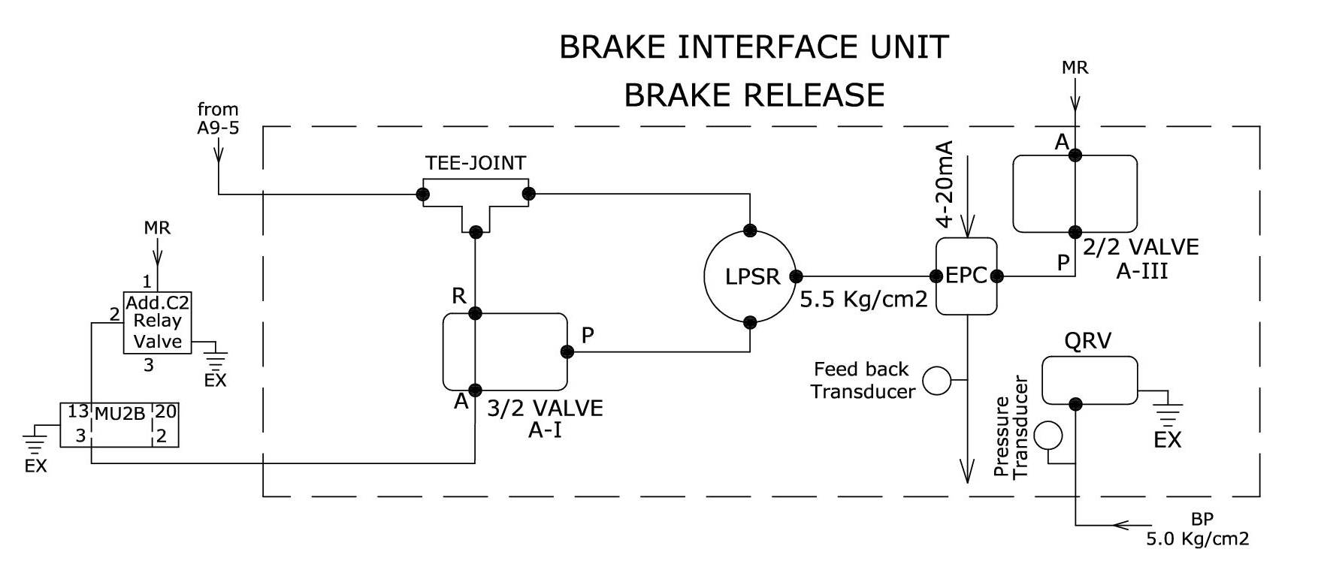

    - In the Brake Release condition, 3/2 Valve A-I is de-energized. In this condition, Port No. 5 of A9 Valve is connected directly to the Addl. C2 Relay Valve.
    - The BP is charged to 5Kg/Cm², and hence, brake is released.

  - Service Brake Application

    - When a train control system initiates Service Brake, the two solenoid valves (3/2 Valve A-I and 2/2 Valve A-III) are energized.
    - This brings EPC and LPSR into active mode, as follows.
      - Port No. 5 of A9 Valve is connected to one inlet port of LPSR through the Tee-joint.
      - EPC receives MR pressure through 2/2 Valve A-III. Outlet of EPC is connected to second inlet port of LPSR.
      - Output of the LPSR is connected to Addl. C2 Relay Valve through 3/2 Valve A-I.
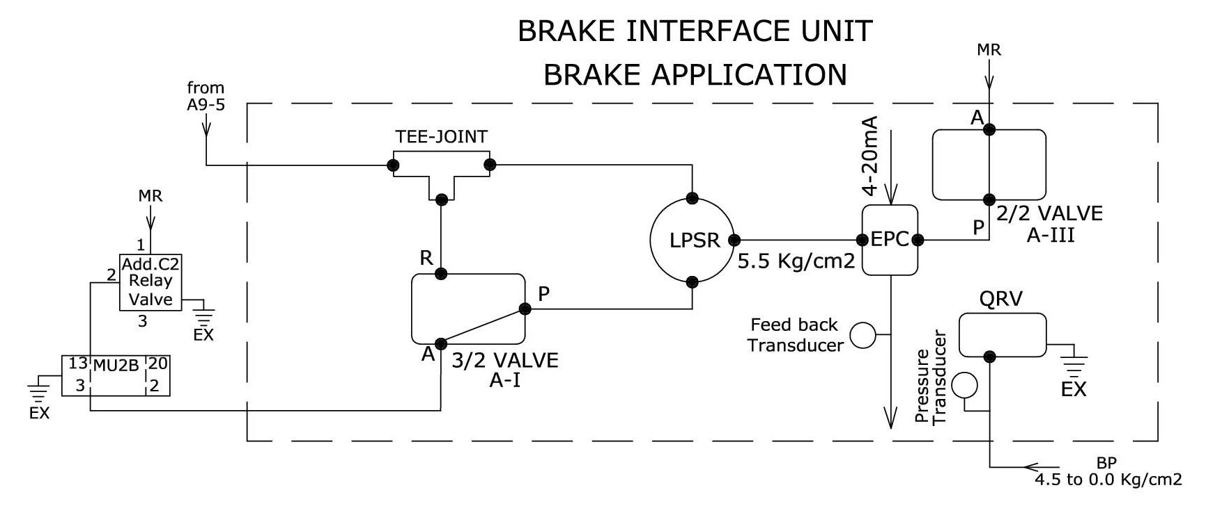

    - EPC-1 receives a current input signal from UBIU electronics, in the range from 4 to 20 mA, and outputs a proportional pressure signal to the LPSR.
    - LPSR chooses the lower of the two pressures (Output from A9 Valve and output from EPC-1) and passes on the pressure to the Addl. C2 Relay Valve. Since pressure at first inlet port is 5Kg/Cm² and at second inlet port it varies from 4.5 to 0 Kg/Cm², air bleeds from BP to EPC through Addnl. C2 Relay Valve, 3/2 Valve A-I and LPSR, as shown in the above diagram.
    - The BP pressure is, thus, controlled according to the train control system command.
    - However, Loco Pilot has got overriding facility through A9 by reducing the BP pressure to lower level than given by train control system command.
    - UBIU electronics monitors the BP pressure through a pressure sensor, and adjusts the 4 to 20 mA current signal in order to obtain optimal braking effort. UBIU electronics also monitors the BC pressure through another transducer.
    - During LE operation, in this design, TCAS gives signal to brake unit for BC build-up along with BP drop through NB application by EPC. Normally, the BC pressure is controlled by the IRAB braking system, depending on the BP pressure. However, in case of any mal-function, if the UBIU electronics senses that BC pressure rises more than 0.5Kg/Cm², without a corresponding drop in BP pressure, UBIU electronics will automatically command EPC-1 to apply NB with auto regression. This will drop the BP pressure and avoid damage to train operations.

  - Emergency Brake

    - When Emergency Brake is applied by train control system, the QRV valve is de-energized, causing BP pressure to exhaust to atmosphere.
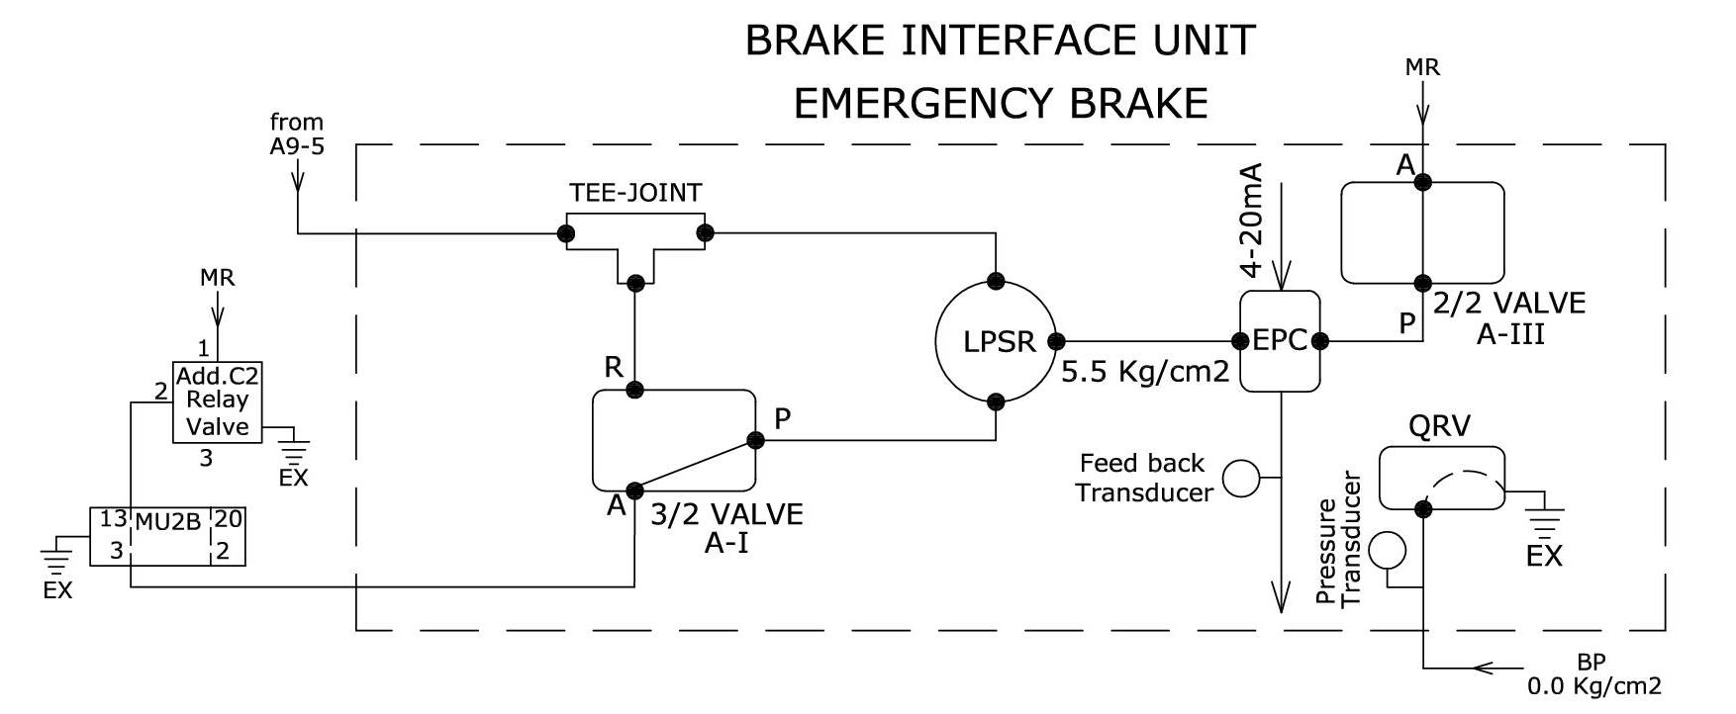
    - This makes the application of emergency brake fail-safe.

    - In order to make the Emergency Brake application more reliable, the Service Brake circuit is also operational by regulating the EPC input signal to 4mA. This will ensure that emergency brake application is at a faster rate.

  - Light Engine Brake
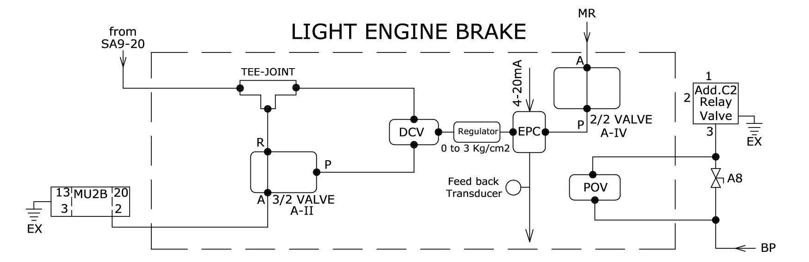
    - When LE mode is selected by the Loco Pilot on the TCAS DMI, TCAS uses the Light Engine brake unit for adequate braking.
    - The Light Engine brake circuit consists of EPC-2, a Pressure Regulating Valves (PRV) set to 3Kg/Cm² pressure, a double check valve and a 3/2 Valve. This circuit is introduced in the SA9 path, as shown in the complete pneumatic circuit.
    - While running as LE, the 3/2 Valve is in de-energized condition.
    - During application of brakes in LE mode, 3/2 Valve is energized, thus connecting PRV set at 3Kg/Cm² pressure to brake cylinders through double check valve (DCV), MU2B, DCV & C2 relay valve. Simultaneously, NB application through EPC is also energized in the main UBIU.
    - The output of SA9 is also connected as another input to DCV. The DCV selects higher pressure out of the two inputs ie., SA9 pressure 3.5Kg/Cm² from loco pilot operation or 3Kg/Cm² from UBIU. The DCV shall be of RDSO approved make.
    - This arrangement ensures adequate braking effort from TCAS in LE mode by building BC pressure up to 3Kg/Cm² within 4 to 6 seconds, while also allowing the loco pilot to over-ride and increase the braking effort. During normal LE operation, pilot can apply brakes through SA9.
    - In order to release the LE brake, the 3/2 solenoid valve in LE Unit and NB application through EPC are de-energized.
There is no possibility of excessive buildup of BP or BC in this design. Provision of LPSR in BP circuit will avoid excessive buildup more than 5kg/cm². Even in BC circuit, PRV provided in LE unit is of M/s. SMC make which is very reliable. There is also locking arrangement for setting to avoid its disturbance on run. However, EPC-2 connected in series with the PRV, prevents even the remote possibility of excessive BC pressure built up due to failure of the PRV.

- UBIU – Electrical Circuit
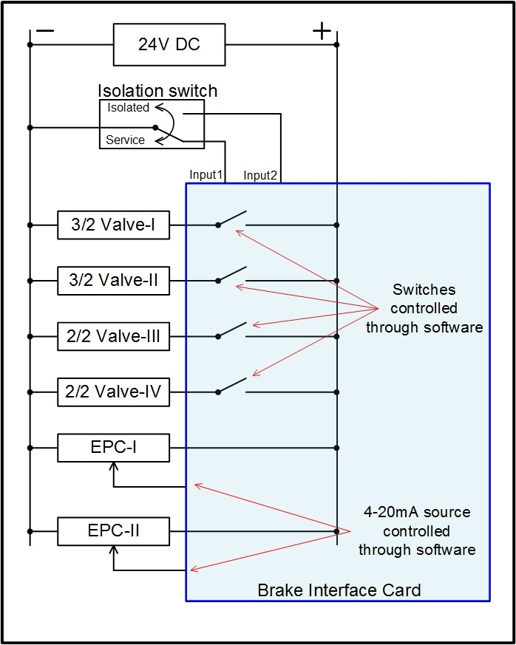
  - The UBIU electrical circuit consists of a microcontroller based electronic Brake interface card and an Isolation Switch
  - Pressure sensors in critical areas of the braking system provide feedback to the BIC card for health monitoring and reporting.
  - The Brake interface card is connected to the train control systems through CAN communication interfaces.
  - For connecting with HBL’s loco TCAS vital computer, a separate serial port, based on RS485 interface, is provided.
  - The figure shows the interface of solenoid valves, isolation switch and EPCs with the brake interface card.

  - The status of the two inputs from the isolation switch (Input1 and Input2) is monitored by the BIC.
  - The operating state of UBIU is decided by BIC as per Input1 and Input2, read from isolation switch, as shown in the following table.

Input 1 | Input 2 | UBIU Status | Remarks
Low | High | In service | -
High | Low | Isolated | -
Low | Low | Faulty | EB is applied if this fault is detected.  Loco pilot has to manually isolate the UBIU by operating the isolation cocks provided in  - the BP output line from UBIU and  - MR input line connected to UBIU  Notes:  - Above is applicable for UBIU interfaced with HBL’s TCAS only.  - If UBIU is connected to a non-HBL TCAS, the UBIU fault status will be communicated through CAN port, and action taken will depend on the implementation of non-HBL TCAS.
High | High | Faulty

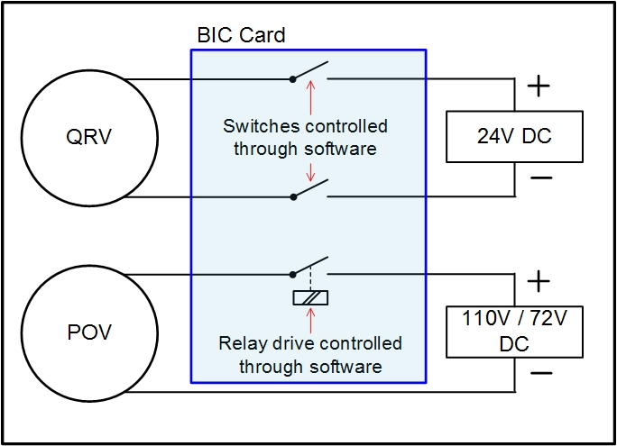
  - All the solenoid valves are controlled through software in the brake interface card. The 3/2 solenoid valves are controlled by the UBIU as per braking commands received from train control systems. Therefore, these solenoid valves operate only when the UBIU is in service (Isolation Switch not operated).
  - The 2/2 solenoid valves operate as long as the Isolation Switch is in the Service position. Whenever the Isolation Switch is in the Isolation mode, the 2/2 valves are turned off by the brake interface card, thus isolating the UBIU from the Loco braking system.
  - The EPCs (Electro-pneumatic controller) are controlled by current input signals in the range of 4 to 20 mA. The EPC builds the pressure at its output port proportional to the input current fed to it.
  - The QRV is a solenoid valve with a normally open port. When energized, the outlet port is blocked. The QRV is operated through a combination of two switches as shown in the figure.
  - For normal operation, the QRV should remain energized so that the brake pipe pressure is maintained. When UBIU is isolated using the Isolation Switch, the QRV is still kept energized.
  - The Pilot operated valve (POV) is controlled through a separate relay provided on the brake interface card, as shown in the above figure. The POV is energized using loco battery supply (110/72VDC).
  - One of the open contacts of isolation switch is used in UBIU output that controls traction cut off. So whenever UBIU is isolated through this switch, the traction cut off output from UBIU also gets physically isolated from the loco circuit.
  - The following table shows the condition of each of the solenoid valves under various conditions of braking. Letter E indicates that the valve is energized, while D indicates that the valve is de-energized.

Position | UBIU Solenoid Valves |  |  |  | QRV | EPC-I | EPC-II
Position | 3/2 valve A- I | 3/2 valve A- II | 2/2 valve  A- III | 2/2 valve  A- IV | QRV | EPC-I | EPC-II
A9-release | D | D | E | E | E | E | D
A9-Application | E | D | E | E | E | E | D
A9-Emergency brake | E | D | E | E | D | E | D
SA9 release | D | D | E | E | E | E | D
**SA9 Application | E | E | E | E | E | E | E
SA9 Emergency brake | E | E | E | E | D | E | E
UBIU isolation | D | D | D | D | E | D | D

** Note:
In the case of SA9 brake application with UBIU, the BP pressure is also controlled (dropped) to ensure safe operation. Hence, 3/2 solenoid A-I and EPC-I are also energized by the brake interface card during SA9 brake application.

- Electronics in UBIU
The figure below shows the interface of electronic modules in UBIU.
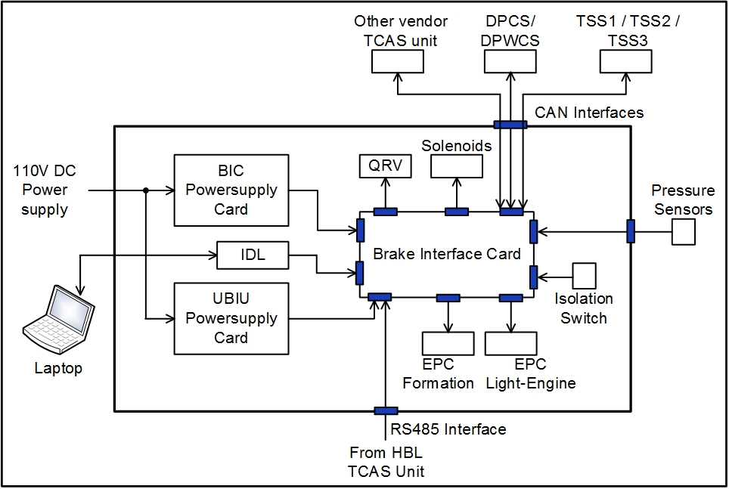
A brief description of each electronic module is given below.
  - Brake interface card (BIC).
    - The brake interface card is the heart of the UBIU system. This module is micro-controller based and performs the following functions.
    - BIC interfaces with train control systems through communication channels, i.e., optically isolated CAN ports. The BIC card interfaces with HBL’s loco TCAS on RS-485 communication link using optically isolated ports. CAN interface protocol in BIC is implemented as per Annexure I of RDSO specification no: MP.0.01.00.31 (Rev.00) December 2014.

    - BIC drives the solenoids and controls Electro-pneumatic controller (EPC) operations for commanding the formation and LE braking operations, as explained above in sections 5 and 6. The brake commands are received from respective train control systems.
    - For any brake application, the BIC card also generates an output by extending potential-free relay contacts, which are used externally to cut off traction. When brake is released, these outputs are withdrawn.
    - The BIC also logs events and errors in the integrated data logger (IDL) with date and time stamp from a built-in battery-backed-up real time clock.
    - The air pressure in MR, BP, BC & A9 reference and airflow in loco feed-pipe, is sensed by BIC through pressure sensors.
    - BIC deduces the loco pilot’s SA9 reference pressure, by calculating the difference in BC pressure and pressure output of EPC-II.
    - BIC card Interfaces with an electromechanical counter for registering the number of times UBIU is isolated.
    - The BIC card interfaces with UBIU isolation switch. It also receives feedback from MR and BP isolating cocks, through switches.

    - UBIU braking effort versus Loco Pilot braking effort:
      - One of the requirements is for UBIU to communicate to the DPCS whether the braking effort from loco pilot is higher or lower than the system braking effort.
      - UBIU has several sensors fitted inside the unit to measure pressures at different locations, and determine whether the UBIU is developing more braking effort or the loco pilot is demanding more. This information is communicated to DPCS, through a CAN packet.
  - IDL (Integrated data logger)

    - Integrated data logger module logs all the events and errors received from the Brake interface card.
    - IDL also interfaces with external laptop/PC on Ethernet port, for programming of the real-time clock in BIC and also for retrieving of event and error log.

  - BIC power supply card
    - This is a power supply card that converts the loco battery supply 110V/72V in electric/diesel loco to 24volts output.
    - This power supply card is used for powering the UBIU solenoids.

  - UBIU Power Supply Card

    - The UBIU power supply card uses the loco battery supply 110V/72V in electric/diesel loco and generates 24V output.
    - The 24 volts output from this power supply is used for powering the Brake interface card.

- COMPLIANCE WITH SAFETY REQUIREMENTS

  - Fail Safety
    - If there is loss of electric power, UBIU automatically applies emergency brake through the QRV.
    - If there is a loss of communication between Loco TCAS unit and UBIU, UBIU electronics will automatically cause the emergency brake to be applied.
    - For any brake application, UBIU activates a control signal that is used externally in the loco system for generating traction cut off in electric locos or throttle cut OFF in diesel locos.

  - Health Monitoring
    - The output pressure of the EPC is periodically monitored at short interval, by the UBIU electronics, to confirm that the required pressure is maintained. If this feedback is not correctly received, UBIU electronics will trigger emergency brake. This software feature also allows analyzing events where UBIU commands brake application, but BP does not drop or BC does not rise.
    - UBIU electronics circuit includes power supply health monitoring and appropriate corrective actions.
    - Heart-beat monitoring of pneumatic valves:

      - Brake Interface Card in UBIU monitors voltage and current of each energized valve, once every 200ms.
      - If the voltage and current values of any valve cross defined tolerance limits, the corresponding valve is flagged as unhealthy.
      - If any pneumatic valve in the UBIU is flagged as unhealthy, the entire UBIU will be flagged as unhealthy.
      - In such an event, TCAS displays a message on the DMI that UBIU is unhealthy and will apply Emergency Brake.

  - Isolation
    - The UBIU can be electrically isolated by the use of an Isolation Switch provided on the front panel of UBIU.
    - Operation of the Isolation Switch also causes all the solenoid valves, except QRV, to de-energize thus isolating the pneumatic system completely. QRV is energized and emergency brake is released. Upon isolation, the original pneumatic circuit of the loco will function under control of the Loco Pilot.
    - UBIU electronics will communicate to the train control system that the UBIU had been isolated. This causes the train control systems to switch to an appropriate mode of operation, as indicated in their respective specifications.
    - UBIU can also be isolated from the pneumatic system through isolating cocks installed in the BP output line from UBIU and MR input line connected to UBIU.
    - The isolation cocks are provided with sensing input connected to the UBIU brake interface card to detect the pneumatic isolation and this information is communicated by UBIU to respective train control systems to switch to the appropriate mode of operation, as indicated in their respective specifications.


TCAS will switch to Standby mode if either of the cocks is closed.

In this condition, Loco TCAS does not provide train protection features.
- Dimensional details of UBIU
  - Without mounting arrangement
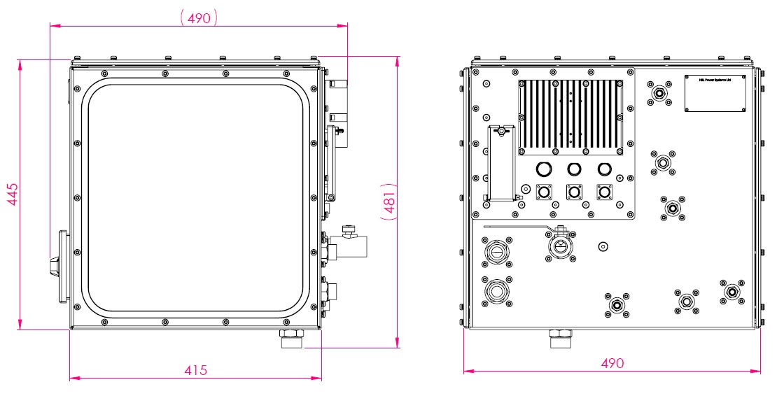
The external dimensions of UBIU are 490 (W) x 481 (H) x 415 (D) mm. The figure below shows the UBIU without the mounting arrangement.

  - With mounting arrangement
As shown below, the mounting arrangement of UBIU is such that it can be easily fitted in the loco, on a rugged stand with shock-absorbing mounts. The details will be included in the installation manual.
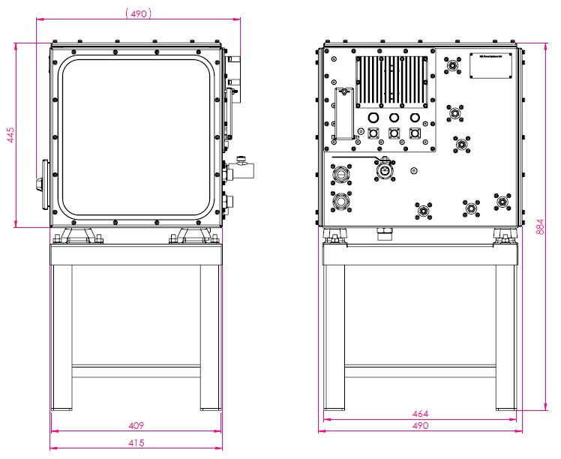

- UBIU assembly with pneumatic components
Pictures of pneumatic components, as assembled in UBIU, are shown below. Wiring details are included in the Installation Manual.
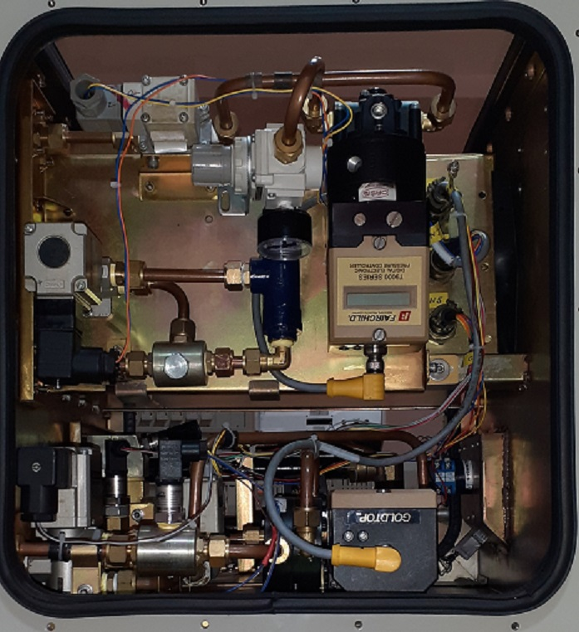
SA9 Control
A-9 Control
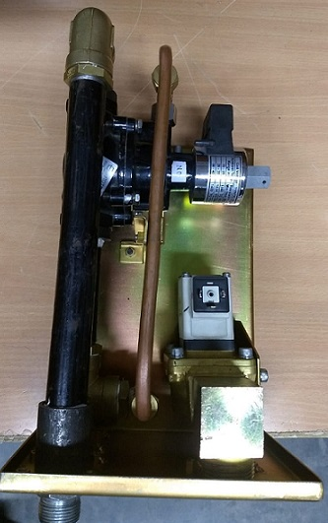
Pilot operated valve (POV) for BP charging cut-off
- Technical Specification Sheets
# | Item | Reference data-sheet
1 | Electronic Pneumatic Controller | 
2 | Low-Pressure Selector Relay(Model:90) | 
3 | Double-check valve (DCV) FTIL make | 
4 | 3/2 Solenoid Valve | 
5 | 2/2 Solenoid Valve | 
6 | Quick Release Valve (QRV) | 
7 | Pilot Operative Valve (POV) | 
9 | Ball valve Isolating cock | 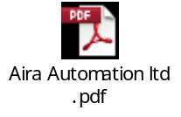
10 | Micro limit switch box with ON/OFF indicator ( to be mounted on ball valve isolating cock) | 

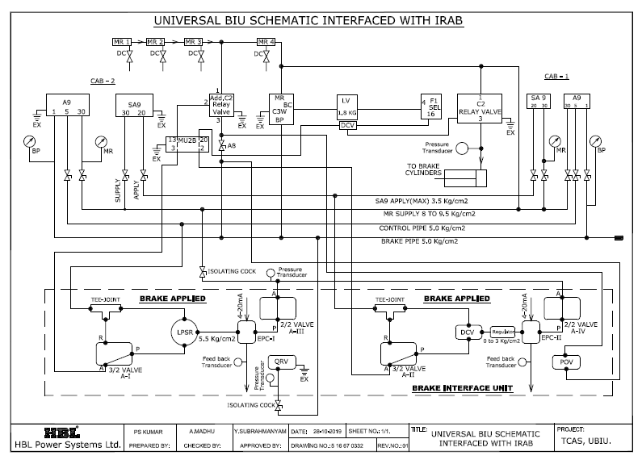
- Schematic diagram of UBIU interface with an IRAB braking system

